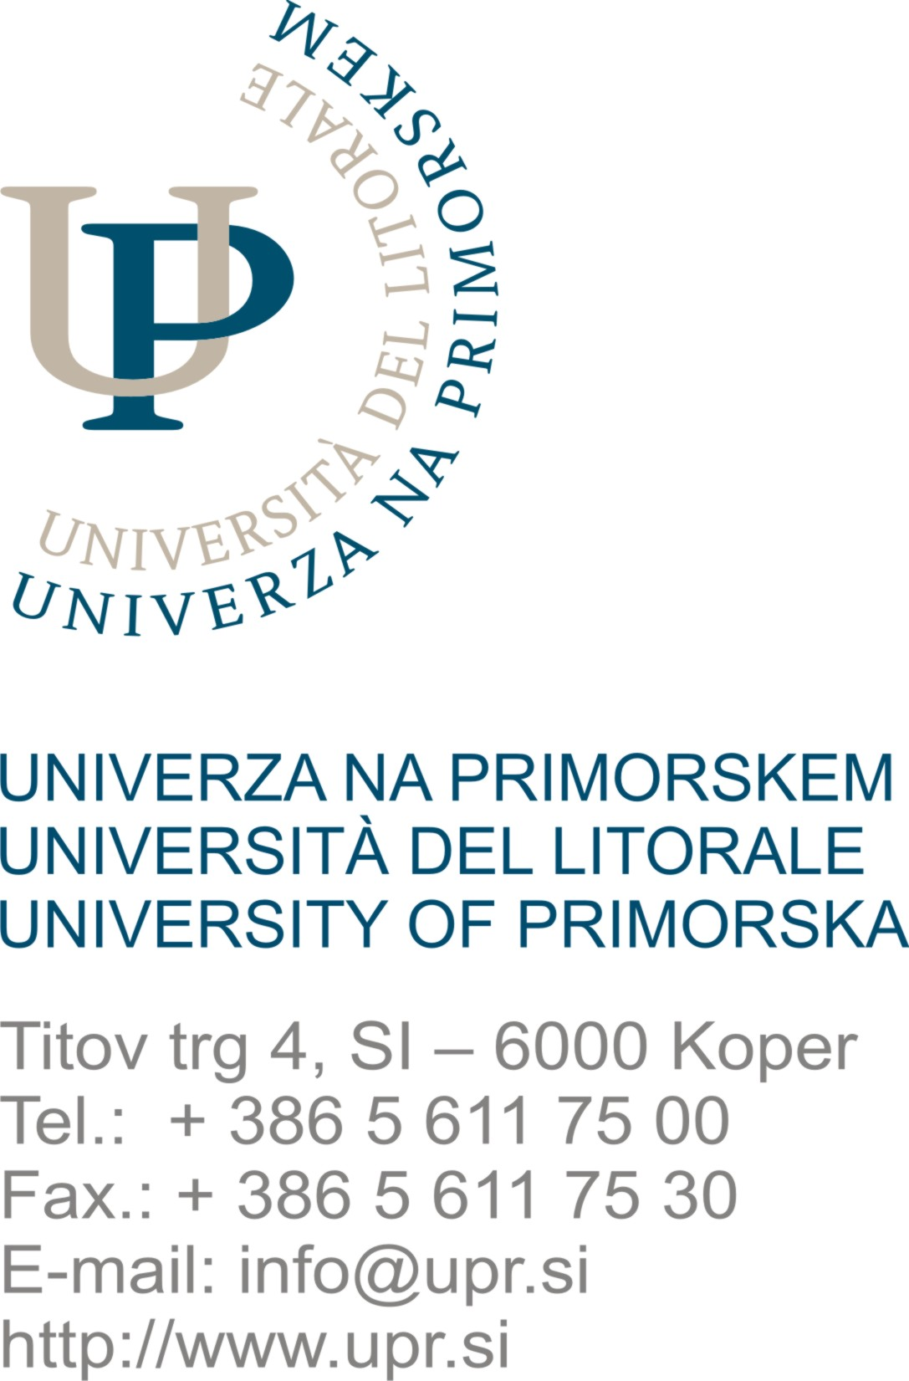
UNIVERZA NA PRIMORSKEM
UNIVERSITÀ DEL LITORALE / UNIVERSITY OF PRIMORSKA
Fakulteta za matematiko, naravoslovje in informacijske tehnologije
FacoltÀ di scienze matematiche naturali e tecnologie informatiche
Faculty of Mathematics, Natural Sciences and Information Technologies
Glagoljaška 8, SI – 6000 Koper
Tel.: (+386 5) 611 75 70
Fax: (+386 5) 611 75 71
www.famnit.upr.si
info@famnit.upr.si

UP FAMNIT STUDENT TUTORING APPLICATION 2021/22

Full name: ____________________________________________________,
registration number: _____________________________,
I am a student in the ______ year
of the study programme: _____________________________________________________________.
I would also like to help foreign students in solving daily life issues: YES NO

Date: _________________ Signature: ________________________________________

Please attach*:
- A short CV,
- printout of grades,
- copies of certificates / diplomas which show your engagement in fields of tutoring or peer support.

* Attachments are mandatory only for students who are applying for the position of student tutor for the first time.

